EXPERIMENT-3

NAME: Thirumala sri.P
ROLL NO:240701569

1.COMMAND LINE INTERFACE:
PYTHON CODE:

import random import string

length = int(input("Enter password length: "))

characters = string.ascii_letters + string.digits + string.punctuation password = ''.join(random.choice(characters) for _ in range(length))

print("Generated password:", password)

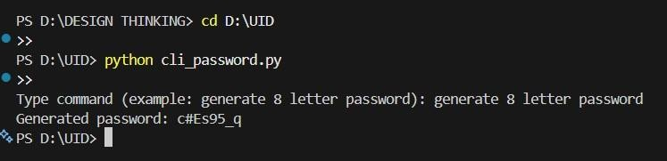

2.GRAPHICAL USER INTERFACE:
PYTHON CODE:

import tkinter as tk
import random import
string

def generate_password():
length = int(length_entry.get()) characters = string.ascii_letters +
string.digits + string.punctuation password =
''.join(random.choice(characters) for _ in range(length)) result_label.config(text=password)

root = tk.Tk() root.title("Password Generator") root.geometry("500x300")

# Top controls top_frame = tk.Frame(root) top_frame.pack(pady=10)

tk.Label(top_frame, text="Password Length:", font=("Arial", 12)).pack(side="left")
length_entry = tk.Entry(top_frame, font=("Arial", 12), width=5) length_entry.pack(side="left", padx=5)

tk.Button(top_frame, text="Generate", command=generate_password).pack(side="left",
padx=5)

# Center display area (your yellow box area) result_label = tk.Label(root, text="", font=("Arial", 28, "bold")) result_label.pack(expand=True)

root.mainloop()

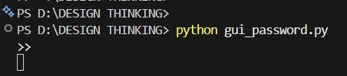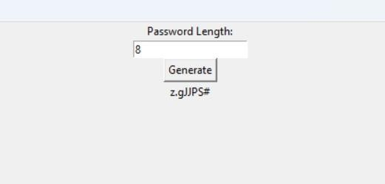

3.VOICE USER INTERFACE:
PYTHON CODE:

import random import string

print("Listening for command to generate a password...")

command = input("Command received: ")

if "password" in command.lower():
characters = string.ascii_letters + string.digits + string.punctuation password = ''.join(random.choice(characters) for _ in range(8)) print(f"Password generated: {password}") else:
print("Sorry, I couldn't understand the command.")

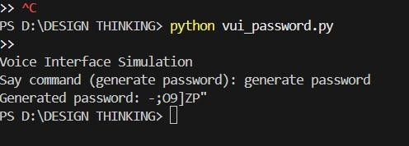

4.USER SATISFACTION COMPARISON:
PYTHON CODE:

def survey():
print("Rate your satisfaction (1-5):")

cli = int(input("CLI: ")) gui = int(input("GUI: ")) vui = int(input("VUI: "))

avg = (cli + gui + vui) / 3

print("\nRatings:") print("CLI:", cli) print("GUI:", gui) print("VUI:", vui) print("Average:", avg)

survey()

